**USER DOCUMENTATION**

**OVERVIEW:**

This is a PHP script that can be executed in command line with various custom arguments. On execution of this script, data from csv file specified using arguments are inserted into the database.

Below are the arguments that can be used while executing script file and their functionalities:

* --file [csv file name] => this argument can be used to specify the csv file name that is to be used to insert data into database.
* --create_table => this argument ensures ‘dbuser’ database and ‘users’ table under that database is created.
* --dry_run => it ensures all the scripts run till end without performing task related to database.
* -u username => it specifies the username to be used in order to connect the database.
* -p password => it specifies the password to be used in order to connect the database.
* -h hostname => it specifies the hostname to be used in order to connect the database.
* --help => this argument can be used in order to display help instructions for other custom arguments.

For example:

**php user_upload.php --file [users.csv] –u root -p pass -h localhost - -create_table**

While using above command, database connection is established using the username i.e. ‘root’, password i.e. ‘password’ and hostname i.e. ‘localhost’. After database connection is established database along with ‘users’ table is created. Finally, csv file is parsed and data is inserted into the ‘users’ table.

**ASSUMPTIONS:**

Database Name: userDb

Table Name: users

Default database username, password and hostname have been set to ‘root’, ‘’ and ‘localhost’ respectively.

**NOTE:**

Script doesn’t allow duplicate entry of email. i.e. two users can’t have same email. All defaults will be overwritten by the passed arguments.

**Requirements:**

Required csv file has to be uploaded in same folder containing user_upload.php

**Some snapshots of the test cases:**

Running script with arguments:

Command: php user_upload.php --file [users.csv] -u root -h localhost --create_table

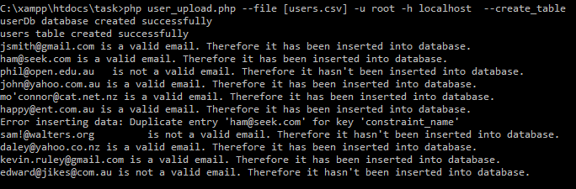

Dry run of the script which ignores data insertion into the database:

Command: php user_upload.php --file [users.csv] -u root -h localhost --create_table --dry_run

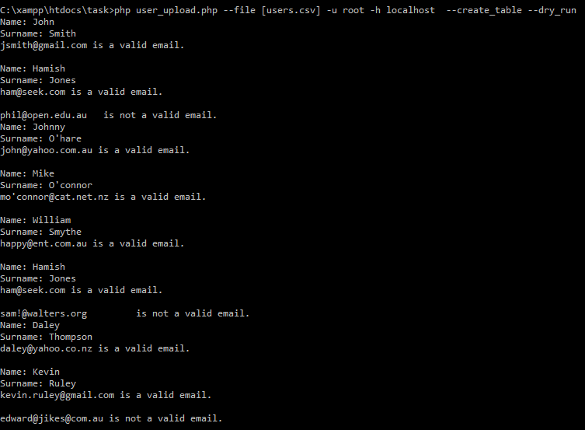

Running help command:

php user_upload.php --help

